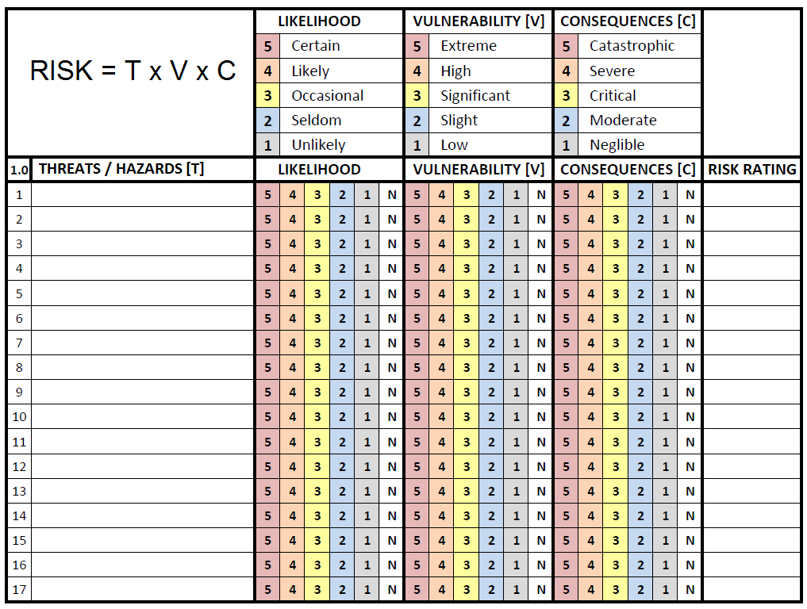
00
00
00
ABC
ABC
ABC

