2/14/2023
Unity Park Splash Pad Maintenance SOP
Working Document
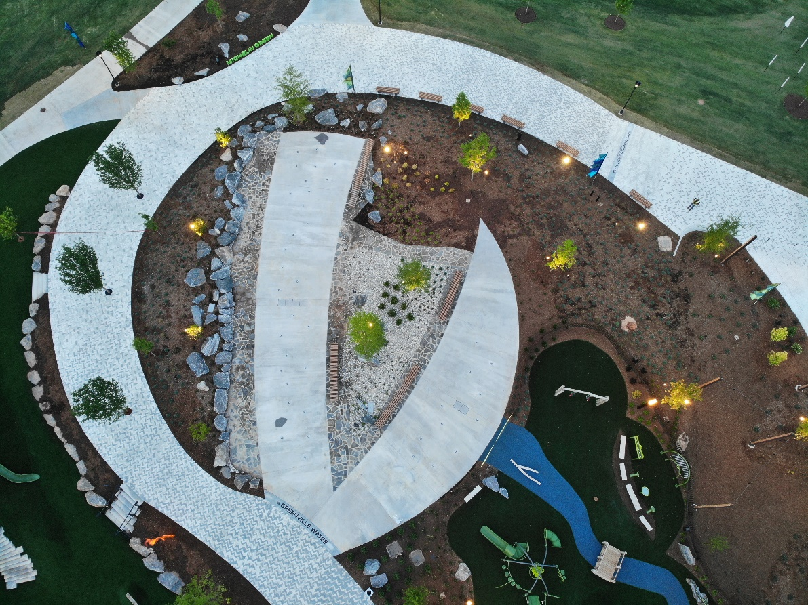


Splash Pad Maintenance

April 15 – April 30

- Pressure wash pad | - Clean jets/main return drains
- Clean Vaults | - Install Probes
- Clean Chlorinators | - Check Programming issues
- Fill Vaults | - De-water pump
- Fill lines in System | - Backwash
- Prepare for Opening | - Fill line
- Order new logbook | - Bring system out of winterization UV-System (Manual)
- Order chemicals needed

May 1 – May 31

- Daily trash check | - Run pool skimmer around in vaults
- M-W-F Clean all jets; check pipe for adequate flow; take jets apart | - Every 3 weeks – Clean Probes (not out of water more than 2 hours – use toothbrush and toothpaste)
- T-TH-S Clean all return drains | - Check levels 2x Daily – Chlorine, PH, CYA Alkalinity 1 week
- SUN Clean chlorinators; check for blockage | - UV System – Check for issue lights
- Skimmer baskets – clean daily in pit/vault

June 1 – June 30

- Daily trash check | - Run pool skimmer around in vaults
- M-W-F Clean all jets; check pipe for adequate flow; take jets apart | - Every 3 weeks – Clean Probes (not out of water more than 2 hours – use toothbrush and toothpaste)
- T-TH-S Clean all return drains | - Check levels 2x Daily – Chlorine, PH, CYA Alkalinity 1 week
- SUN Clean chlorinators; check for blockage | - UV System – Check for issue lights
- Skimmer baskets – clean daily in pit/vault
- SUN Clean chlorinators; check for blockage

July 1 – July 31

- Daily trash check | - Run pool skimmer around in vaults
- M-W-F Clean all jets; check pipe for adequate flow; take jets apart | - Every 3 weeks – Clean Probes (not out of water more than 2 hours – use toothbrush and toothpaste)
- T-TH-S Clean all return drains | - Check levels 2x Daily – Chlorine, PH, CYA Alkalinity 1 week
- SUN Clean chlorinators; check for blockage | - UV System – Check for issue lights  Add chemicals as needed:  - Alkalinity 80-120 ppm (100)  - CYA 30-100 ppm (50)  - PH 7.2-7.8 ppm (7.5)  - Chlorine 3.0-5.0 ppm (5.0)  - Holidays are busy
- Skimmer baskets – clean daily in pit/vault
- SUN Clean chlorinators; check for blockage

August 1 – August 31

- Daily trash check | - Run pool skimmer around in vaults
- M-W-F Clean all jets; check pipe for adequate flow; take jets apart | - Every 3 weeks – Clean Probes (not out of water more than 2 hours – use toothbrush and toothpaste)
- T-TH-S Clean all return drains | - Check levels 2x Daily – Chlorine, PH, CYA Alkalinity 1 week
- SUN Clean chlorinators; check for blockage | - UV System – Check for issue lights
- Skimmer baskets – clean daily in pit/vault
- SUN Clean chlorinators; check for blockage

September 1 – September 30

- Daily trash check | - Run pool skimmer around in vaults
- M-W-F Clean all jets; check pipe for adequate flow; take jets apart | - Every 3 weeks – Clean Probes (not out of water more than 2 hours – use toothbrush and toothpaste)
- T-TH-S Clean all return drains | - Check levels 2x Daily – Chlorine, PH, CYA Alkalinity 1 week
- SUN Clean chlorinators; check for blockage | - UV System – Check for issue lights
- Skimmer baskets – clean daily in pit/vault | - Check call box operation and address
- SUN Clean chlorinators; check for blockage

October 1 – October 15

- Daily trash check | - Skimmer baskets – clean daily in pit/vault
- M-W-F Clean all jets; check pipe for adequate flow; take jets apart | - SUN Clean chlorinators; check for blockage
- T-TH-S Clean all return drains | - Run pool skimmer around in vaults
- SUN Clean chlorinators; check for blockage

Closing procedure

- Turn off main disconnect | - Clean Chlorinators
- Drain vaults; de-water pump | - Pump out Vaults (ShopVac)
- Drain all lines, filter, jet pumps | - Pressure wash pad/drains
- Drain 10 inch line in Pit (Plug bottom center) | - Walk through double check clean/off/empty
- Drain Pool filters (Pull plug on line to filters)
- Store Probes (cup of water)

